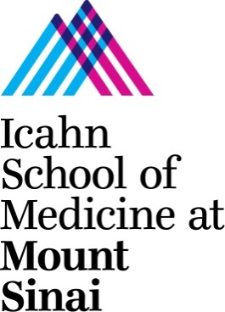
Andrew Sharp, PhD, Associate Professor
Director of Graduate Program in Genetics and Genomic Sciences
Dept. of Genetics and Genomic Sciences
Icahn School of Medicine at Mount Sinai
Hess Center for Science and Medicine
1470 Madison Ave, Room 8-116
New York, NY 10029
Telephone: 212-824-8942
Email: andrew.sharp@mssm.edu

March 30th 2017

Dear Sir or Madam,

DNA methylation is a modification to the human genome whereby methyl groups are added to cytosine in DNA. This addition leads to epigenetic modifications, which subsequently effect how genes are expressed. Increasingly, scientists have linked the presence of increased DNA methylation and diseases such as cancer, multiple sclerosis, and Alzheimer’s disease. Uncovering and mapping this link has major implications for the diagnosis and treatment of genetic diseases. At the forefront of this research is Dr. Shicheng Guo, an expert in the field of clinical genetics. Dr. Guo’s work on the DNA methylome of human peripheral blood mononuclear cells (PBMC) is foundational for the study of epigenomics, providing both a wealth of experimental findings as well as a confirmation of whole-genome sequencing as a method for methylome analysis. Dr. Guo has made substantial contributions to the study of DNA methylation, and achieved stunning results through his innovative approach and methodology. His achievements in this field, combined with his experience and knowledge, make him a distinguished and indispensable member of the scientific community.

My name is Dr. Andrew Sharp and I am a Senior Faculty Member and Associate Professor in the Department of Genetics and Genomic Sciences at Mount Sinai School of Medicine. I received my Ph.D. at the University of Southampton. Following my doctoral studies, I was as Senior Fellow in the Department of Genome Sciences at the University of Washington in Seattle and a Marie Curie Fellow in the Department of Genetic Medicine at the University of Geneva. Throughout my career, I have focused on analyzing the human genome for links to human disease. I am particularly interested in using bioinformatics in tandem with experimental data to study structural variation, epigenetics, and gene expression. My research in this area has brought me into contact with the excellent published work of Dr. Guo. I write this letter as an unbiased, independent observer of Dr. Guo’s research as I have never worked with him in any capacity. Thus, I am able to state with authority that Dr. Guo is an exceptional researcher, whose work is advancing the field of clinical genetics.

One example of Dr. Guo’s contribution to the field is his study of the DNA methylome profile of PBMC. In this study, Dr. Guo overcame the innate difficulty of constructing a complete reference for human blood cell methylome in single-base resolution. He achieved this through whole-genome bisulfite sequencing using PBMC from the Han Chinese subject whose whole genome was deciphered as part of the YH project. Dr. Guo then performed a comprehensive analysis of the methylome, looking for unique sequences. He found that 68.4% of CpG sites were methylated, while less than 0.2% of non-CpG sites were methylated. This demonstrates that non-CpG cytosine methylation is minimal in human PBMC. Dr. Guo then profiled 20 distinct genomic features with PBMC methylome, including regulatory, protein-coding, non-coding, RNA-coding, and repeat sequences. Dr. Guo discovered a high level of co-methylation in the human genome that was not affected by underlying CpG density. He did find, however, that co-methylation deteriorated over distance, becoming nearly undetectable at distances greater than 1,000 bp. Integrating his data with the YH project’s genome sequence, Dr. Guo completed the first comprehensive assessment of allele-specific methylation (ASM) between two haploid methylomes of any one individual. He identified 599 haploid differentially methylated regions (hDMRs) covering 287 genes. Among these, 76 genes had hDMRs within 2kb of their transcriptional start site, more than 80% of which displayed allele-specific expression (ASE). Dr. Guo concluded that in human PBMCs, ASM is a recurrent phenomenon that is highly correlated to ASE. Dr. Guo’s research, which was published in PLOS Biology, is a major resource for scientists studying DNA methylation, having provided not only a model for sequencing in large-scale epigenomic studies, but also a rich methylome reference for use in identifying biomarkers in human diseases. The study’s utility for further research is clearly demonstrated by the number of citations it has received, which to date is nearly 250.

Scientists who have relied on Dr. Guo’s findings to conduct subsequent studies on DNA methylation have used his results in a variety of ways. I cited Dr. Guo’s study in an article for Genome Research title “DNA methylation profiles of human active and inactive X chromosomes.” I used his findings on the methylation levels of expressed vs. inactive genes to explain my experimental results. In addition, a study by Heyn et al. published in the Proceedings of the National Academy of Sciences of the United States of America cited Dr. Guo’s data and results to further their correlation between aging and DNA methylation. As these citation examples show, Dr. Guo’s work on DNA methylation has been central to continuing work on this topic. Without Dr. Guo’s research, therefore, scientists in this field would be at a significant disadvantage.

Understanding DNA methylation is vital to continuing to develop more effective and efficient ways to diagnose and treat devastating human diseases, including cancer. Early diagnosis and therapy strategy selection are especially benefitted by research into the DNA methylome, and Dr. Guo’s study has demonstrated not only an advanced method for this research, but has also provided a wealth of genomic data that researchers are already utilizing. The United States spends upwards of $125 billion on cancer care annually, with expenditure trends increasing every year. Dr. Guo’s research aims to reverse those trends by providing early detection of cancer, which leads to better outcomes for cancer patients. As such, his work provides a clear benefit to the United States and its citizens. I therefore strongly advise against any obstruction of Dr. Guo’s progress in this important and life-saving work.

Sincerely,

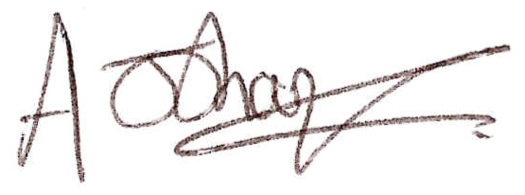

Andrew Sharp, Ph.D.

